

**Dynamics 365 – Purchase Order Receiving and Shipment Tracking**

**Revision 1**

**Revision History**

|  |  |  |  |  |
| --- | --- | --- | --- | --- |
| **Date** | **Revision** | **Description** | **Signature / Date** | |
| 25/03/2022 | 1 | Initial draft of user manual: Purchase Order Receiving and Shipment Tracking | Prepared | Salman Tahir |
|  |  | Verified |  |
|  |  | Approved |  |
| 24/10/2022 | 2 | User manual: Purchase Order Receiving and Shipment Tracking | Prepared | Waseem Abbas |
|  |  | Verified |  |
|  |  | Approved |  |
|  |  |  | Prepared |  |
|  |  |  |  |
|  |  |  |  |
|  |  |  |  |  |
|  |  |  |  |
|  |  |  |  |

**Table of Contents**

1 About User Manual 5

2 Product Receipt Creation 5

2.1 Purchase Order Confirmation 5

2.2 Generate Product Receipt 5

3 Product Receipt Update 6

3.1 Product Receipt Journal 6

3.2 Product Receipt Correction 7

3.3 Product Receipt Cancellation 8

4 Product Receipt History 8

5 Shipment Tracking Details 9

5.1 Get Shipment Information 9

5.2 Shipment Tracking 10

5.3 Shipment Detail 15

5.4 Shipment Tracking Details 16

List of Figures

Figure 1. Confirmation of Purchase Order 5

Figure 2. Product Receipt Generation 5

Figure 3. Add require information to Post the Product Receipt 6

Figure 4. Accessing Product Receipt Journal page 6

Figure 5. Product Receipt Journal Page 7

Figure 6. Product Receipt Correction 7

Figure 7. Product Receipt Cancellation 8

Figure 8. Product Receipt History 8

Figure 9. Compare Product Receipt Versions 9

Figure 10 Module Purchase Order Flow 9

Figure 11 Get Shipment Details 10

Figure 12 Shipment Tracking of Purchase Order 10

Figure 13 Apply Filter to find Tracking Number of Purchase Order 11

Figure 14 Add New Line of Shipment Tracking 11

Figure 15 Alert if Tracking Number Already in the List 12

Figure 16 Alert If Shipment Carrier Already Associated 12

Figure 17 Correct Tracking number is Added Successfully 13

Figure 18 Remove Tracking Number from the List 13

Figure 19 Confirmation Popup to Remove the Tracking Number 14

Figure 20 Refresh the Tracking List 14

Figure 21 Shipment Details 15

Figure 22 All Shipment Details 15

Figure 23 Add Remaining Shipment in the List 16

Figure 24 Comparison of Quantity of Purchase Order and Shipment Quantity 16

Figure 25 Shipment Quantity Must Les Then Order Quantity 17

Figure 26 Remove any Part Number from the List 17

Figure 27 Confirmation Popup to Remove the Part Number from the List 18

Figure 28 Refresh the List of Part Number 18

# About User Manual

This document describes the procedure regarding the creation of product receipt and other options like to correct, cancel and check the history of created product receipts.

# Product Receipt Creation

In order to create a product receipt, following steps are involved.

## Purchase Order Confirmation

The first step involved around the creation and confirmation of purchase order. After the PO creation, confirm the Purchase order in order to create the product receipt.

**Navigation**: Modules > Procurement and Sourcing > Purchase orders > All Purchase Orders > Purchase > Action > Confirm

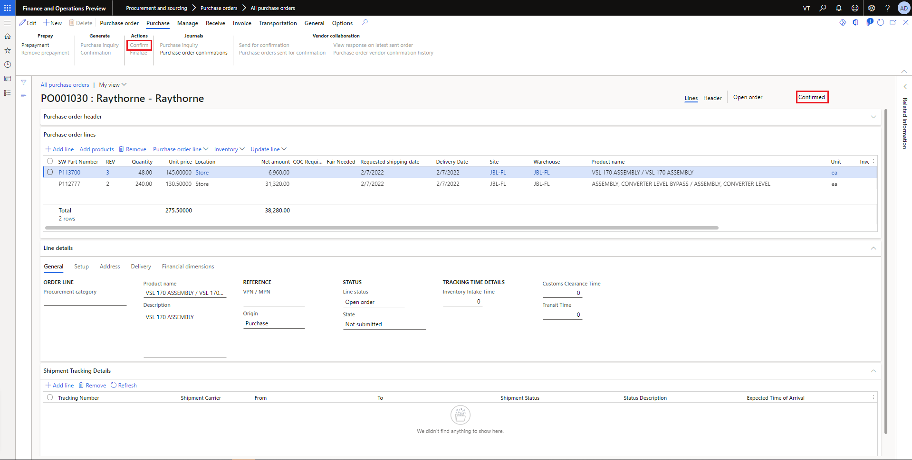

Figure 1. Confirmation of Purchase Order

## Generate Product Receipt

To generate product receipt, go to the ‘Receive’ option available on the top. Select the ‘Product receipt’ option available under ‘Generate’ category.

**Navigation**: Modules > Procurement and Sourcing > Purchase orders > All Purchase Orders > Recieve > Generate > Product receipt

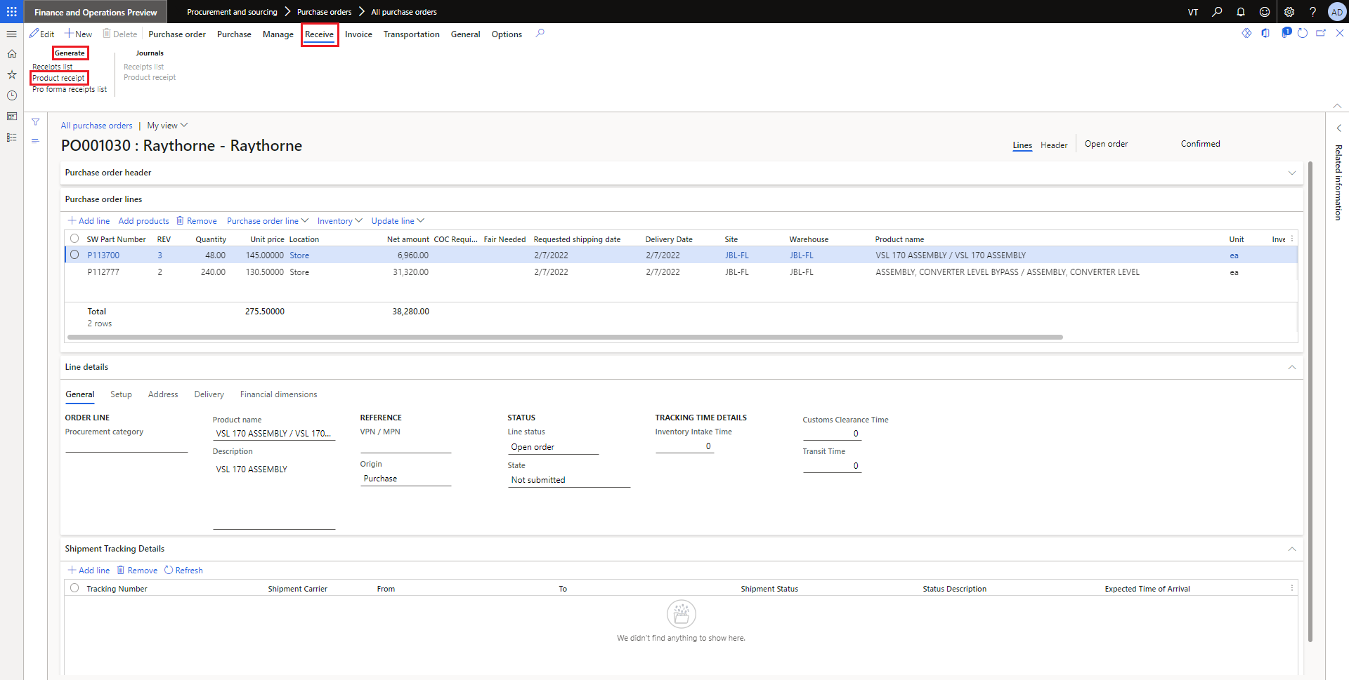

Figure 2. Product Receipt Generation

Enter the name in the ‘Product Receipt’ field. Also add information in the fields of ‘Product receipt date’, ‘Document Date’ and ‘terms of payment’.

In the line items, enter the quantity that you have received. If you have received the complete PO items then keep the quantity field unchanged. In the **Figure** below, sample process for receiving the items.

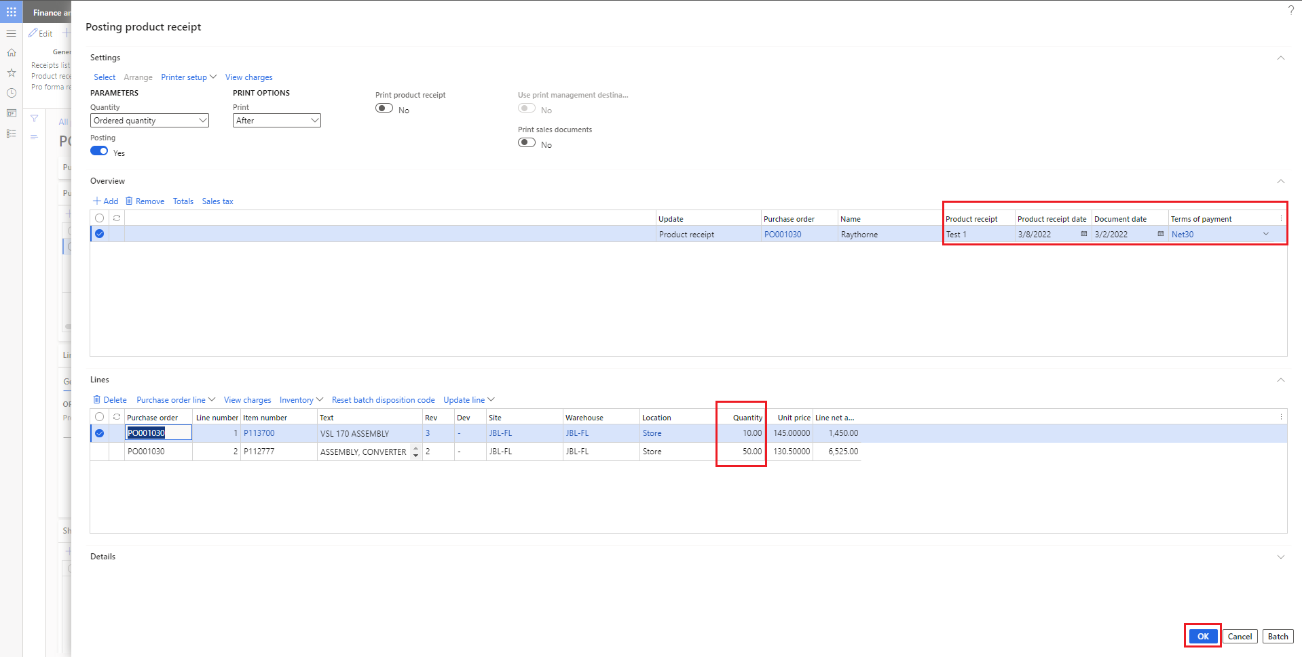

Figure 3. Add require information to Post the Product Receipt

# Product Receipt Update

## Product Receipt Journal

To view the generated product receipt, select the ‘Product Receipt’ available under the Journals.

**Navigation**: Modules > Procurement and Sourcing > Purchase orders > All Purchase Orders > Receive > Journals > Product receipt

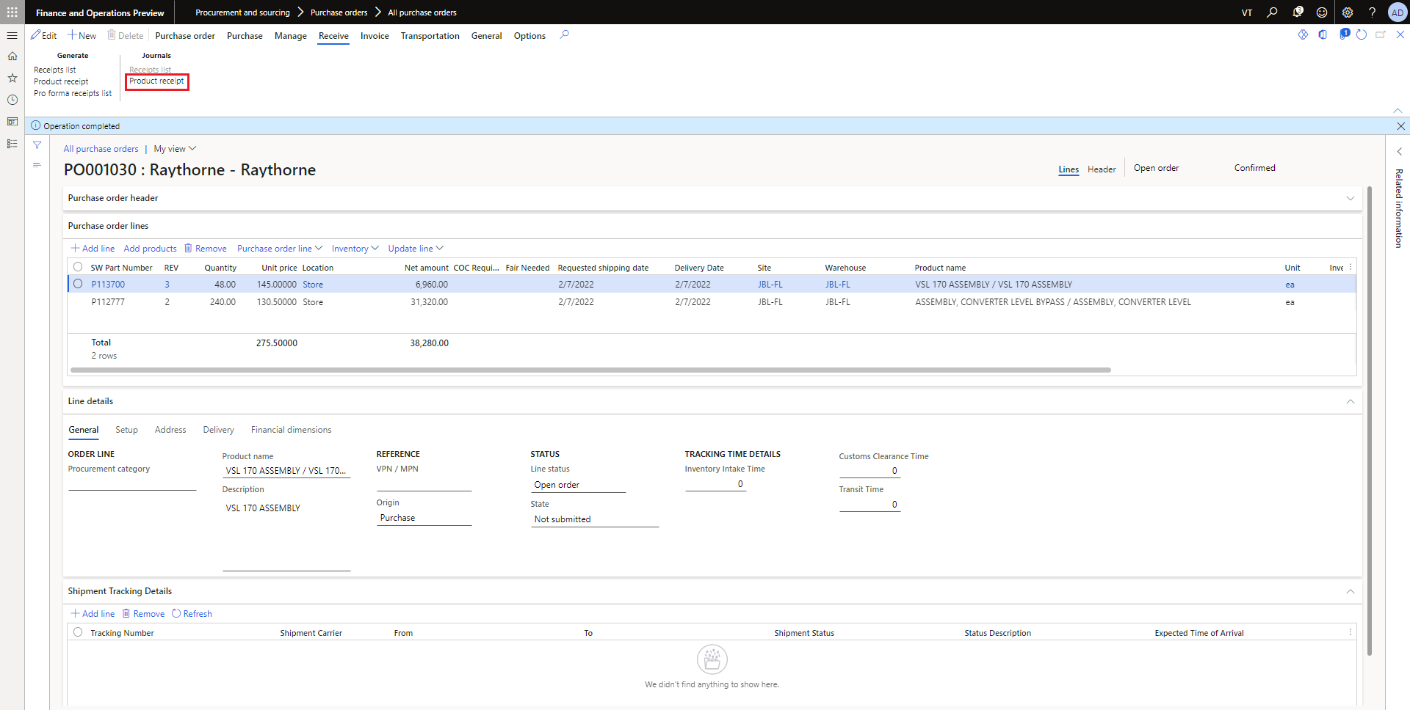

Figure 4. Accessing Product Receipt Journal page

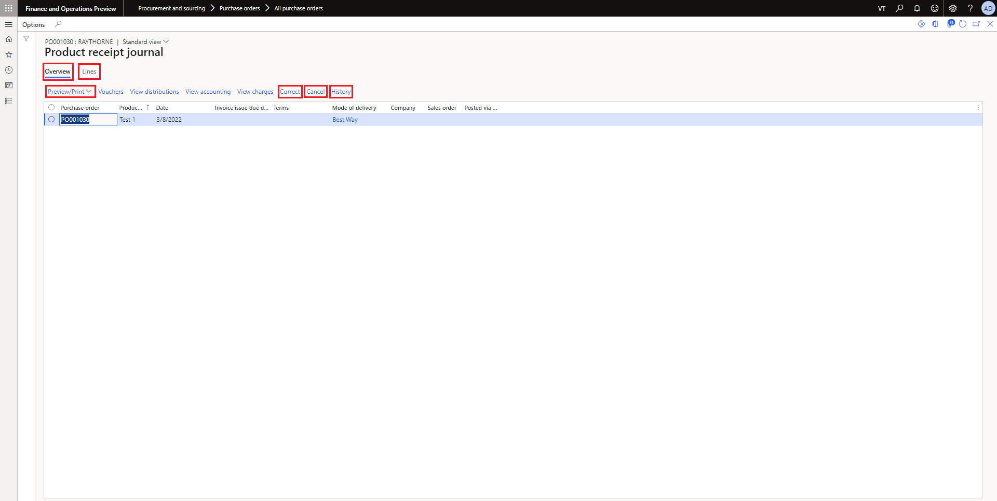

Figure 5. Product Receipt Journal Page

The Journal page will give the overview information and lines details of items that are received. Also, there is an option to Preview/print the product receipt for reference. There are also available options like to correct the product receipt, cancel and check the history of changes in product receipt.

## Product Receipt Correction

Sometimes actual received items are not matched or less in number compared to generated product receipts. To rectify this issue, select the ‘Correct’ option available in the product journal page and enter the actual received items. You only can reduce the received quantity for any product receipt.

Update the ‘Quantity’ field according to the actual item received.

**Navigation**: Modules >Procurement and Sourcing > Purchase orders > All Purchase Orders > Receive > Journals > Product receipt > Correct

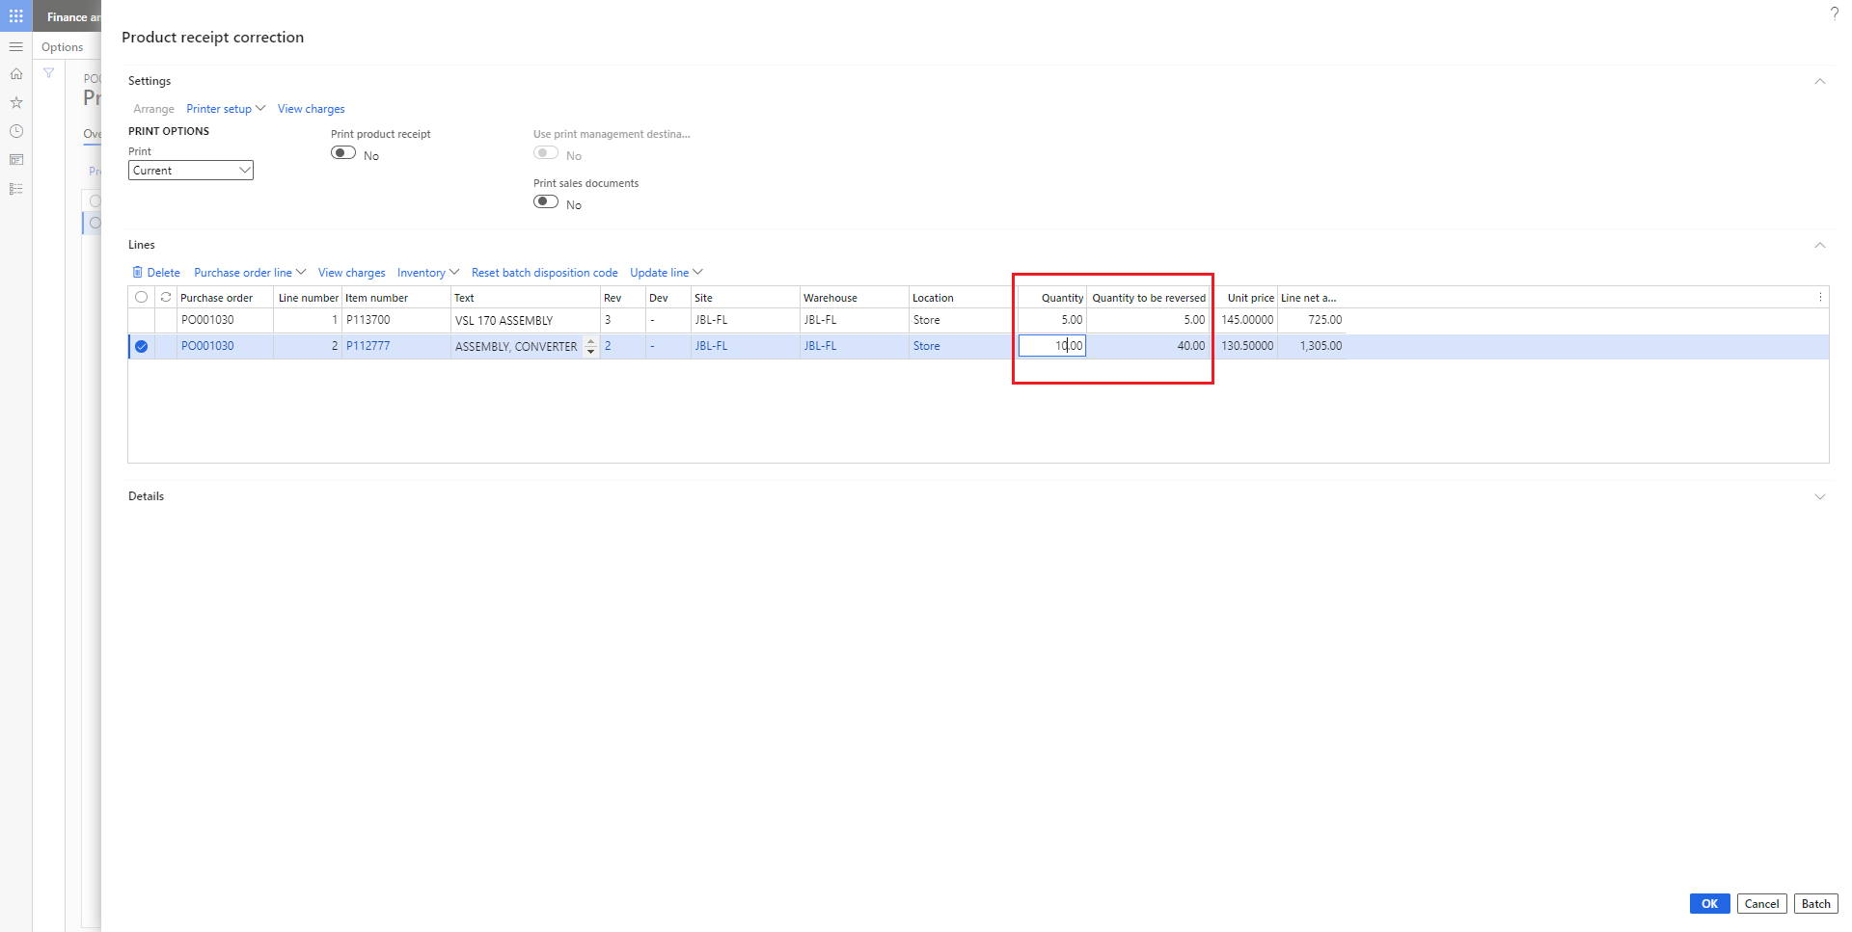

Figure 6. Product Receipt Correction

## Product Receipt Cancellation

In order to cancel the product receipt, select the ‘**Cancel’** option available in the Product Receipt Journal.

**Navigation**: Modules> Procurement and Sourcing > Purchase orders > All Purchase Orders > Receive > Journals > Product receipt > Cancel

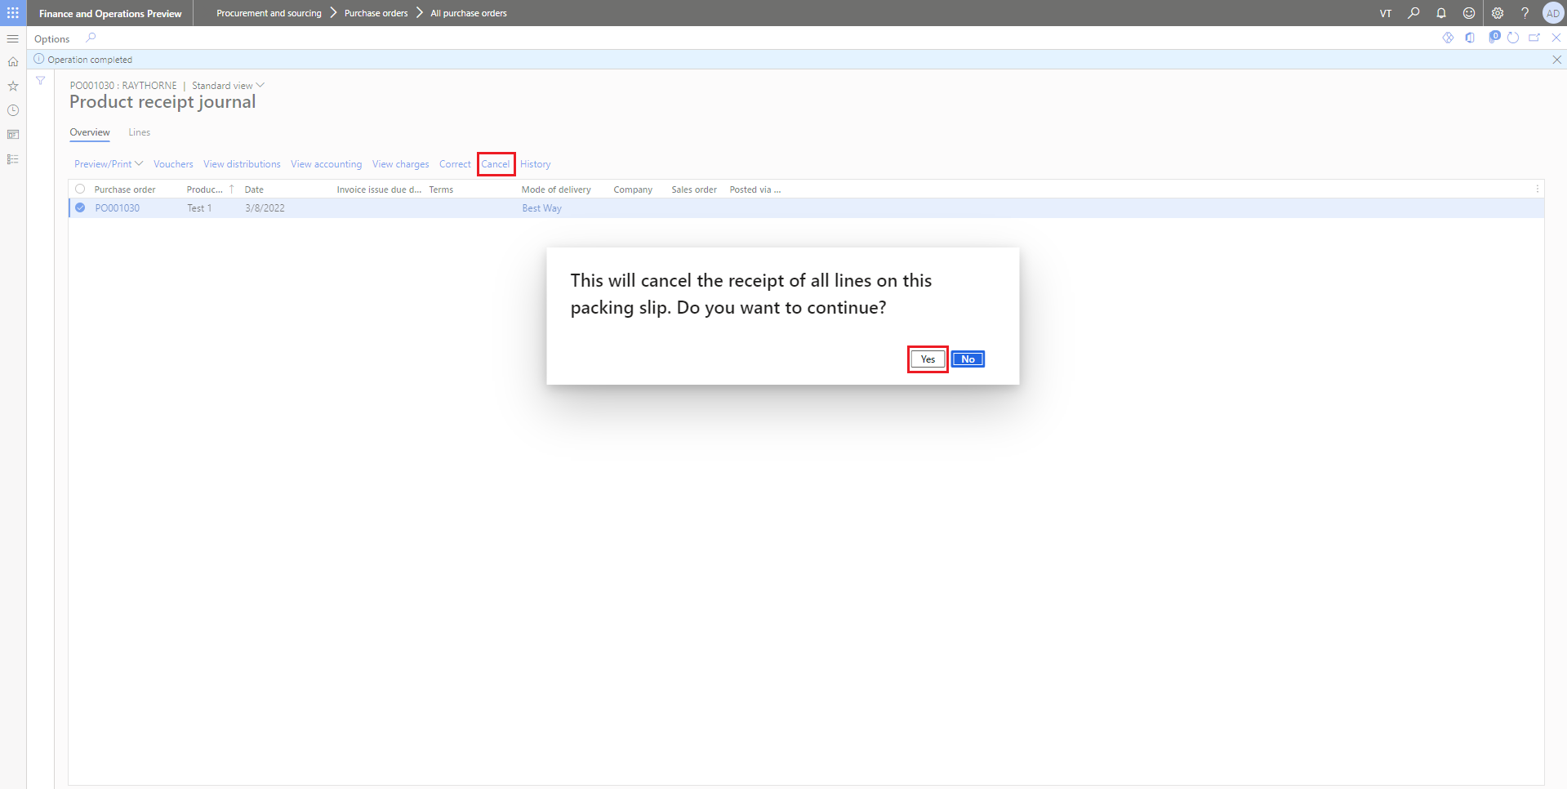

Figure 7. Product Receipt Cancellation

# Product Receipt History

Product Receipt history will show the history of changes that you have made in the product receipt. It will depend on the number of corrections you have made in product history. You can also compare the versions of products receipts.

**Navigation**: Modules > Procurement and Sourcing > Purchase orders > All Purchase Orders > Receive > Journals > Product receipt > History

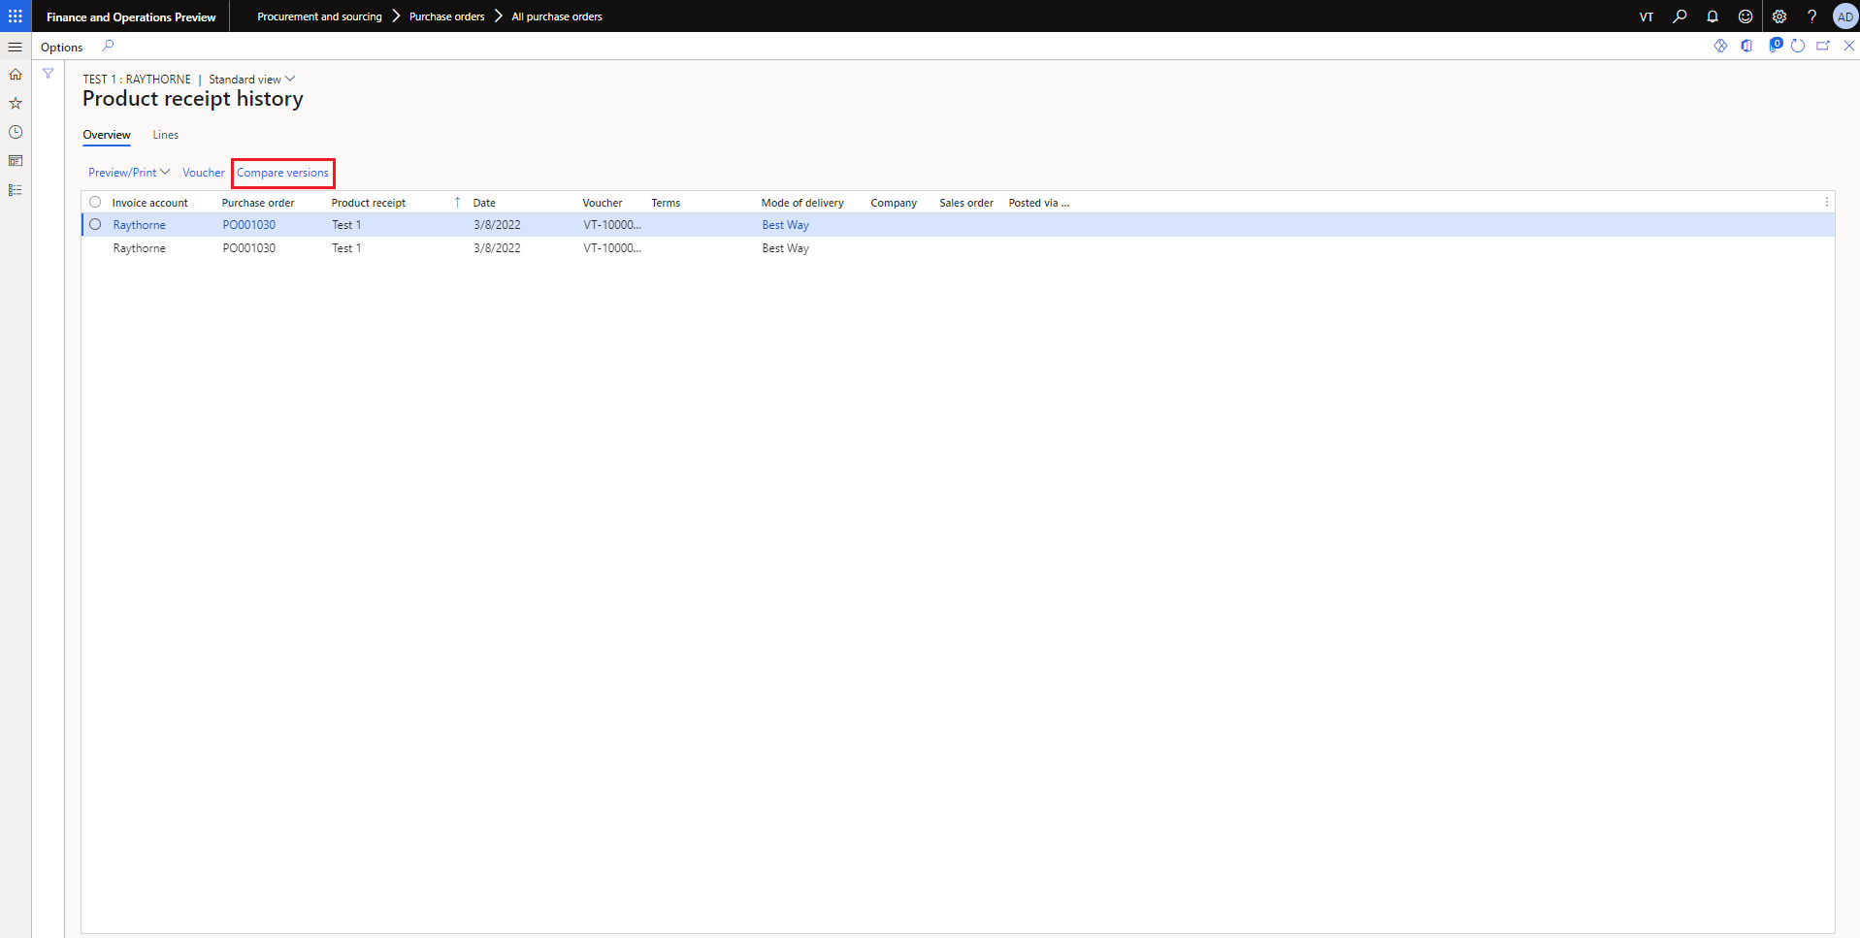

Figure 8. Product Receipt History

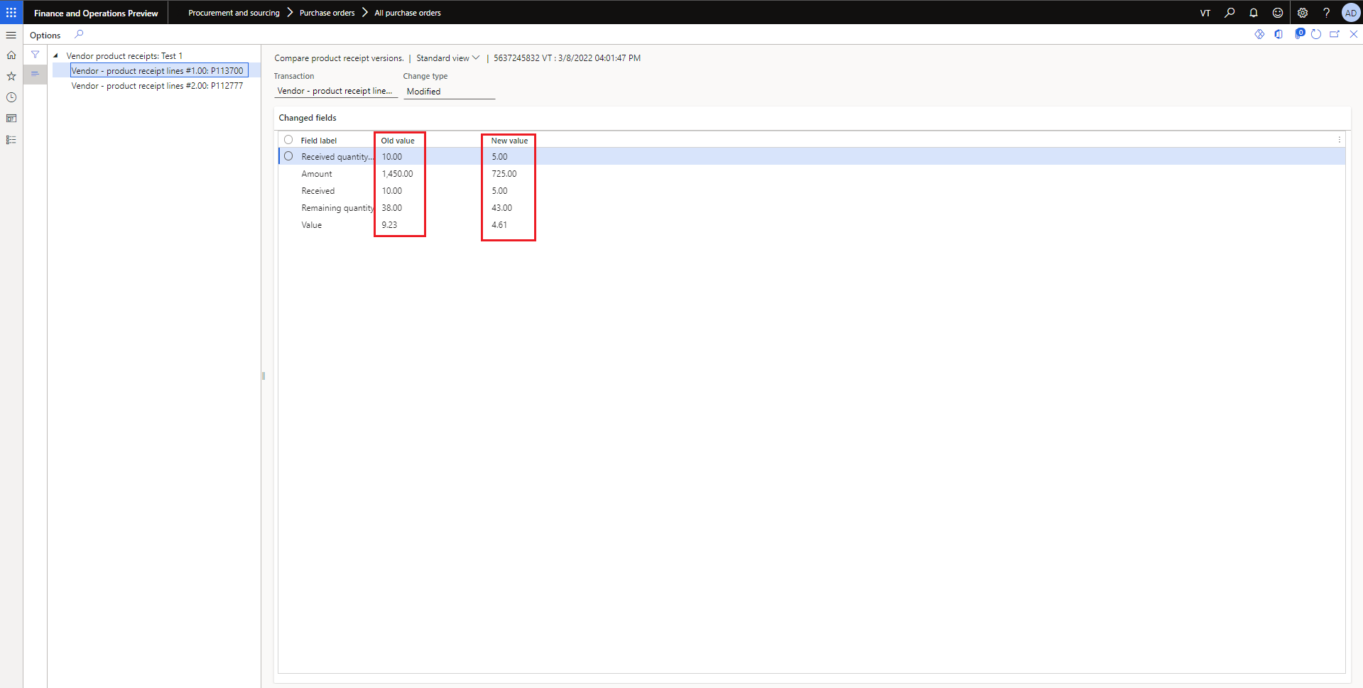

Figure 9. Compare Product Receipt Versions

# Shipment Tracking Details

## Get Shipment Information

Get shipment detail will refresh the data of the purchase orders.

**Navigation**: Modules >Procurement and Sourcing > Purchase orders > Get Shipment

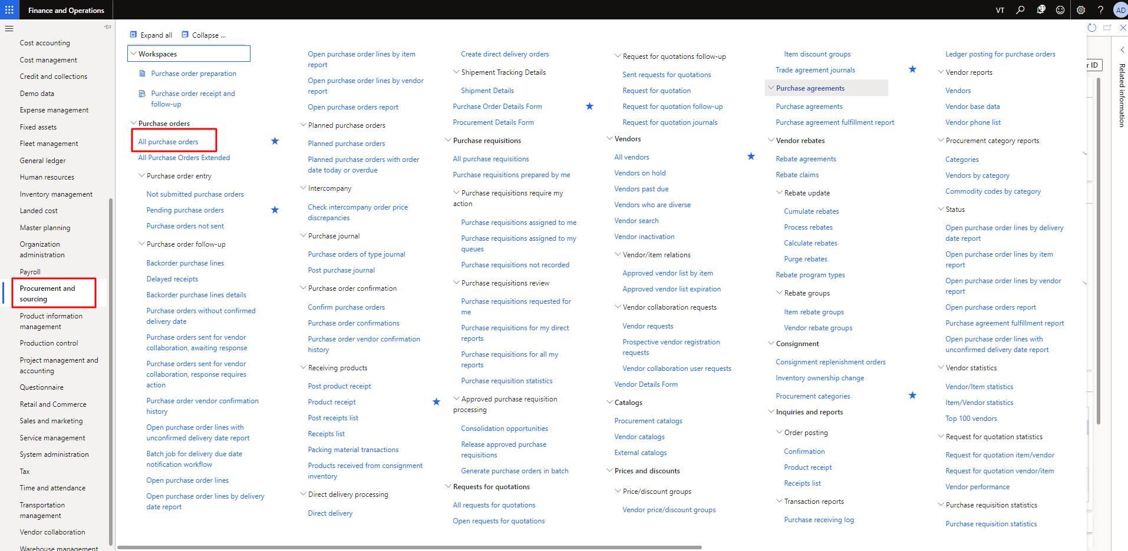

Figure 10 Module Purchase Order Flow

The user needs to click on **Get Shipment Information** to refresh the data or fetch the latest shipment detail. As the user press the Get Shipment Information then Destination will update. Its briefly describe in Shipment Tracking Details **5.4**.

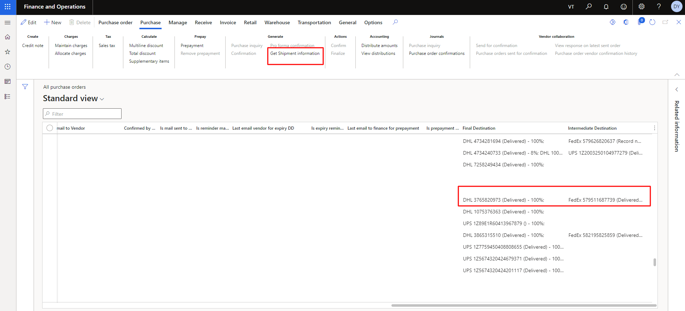

Figure 11 Get Shipment Details

## Shipment Tracking

The user can access the tracking of the of purchase order (PO) by opening the any specific purchase order. In the shipment tracking user can add new, remove and refresh it. The user can’t add any duplicate tracking number nor its courier. Any tracking number have 2 carrier (DHL and FedEx) services. The user can also remove any tracking number from the list as well refresh the list of tracking number.

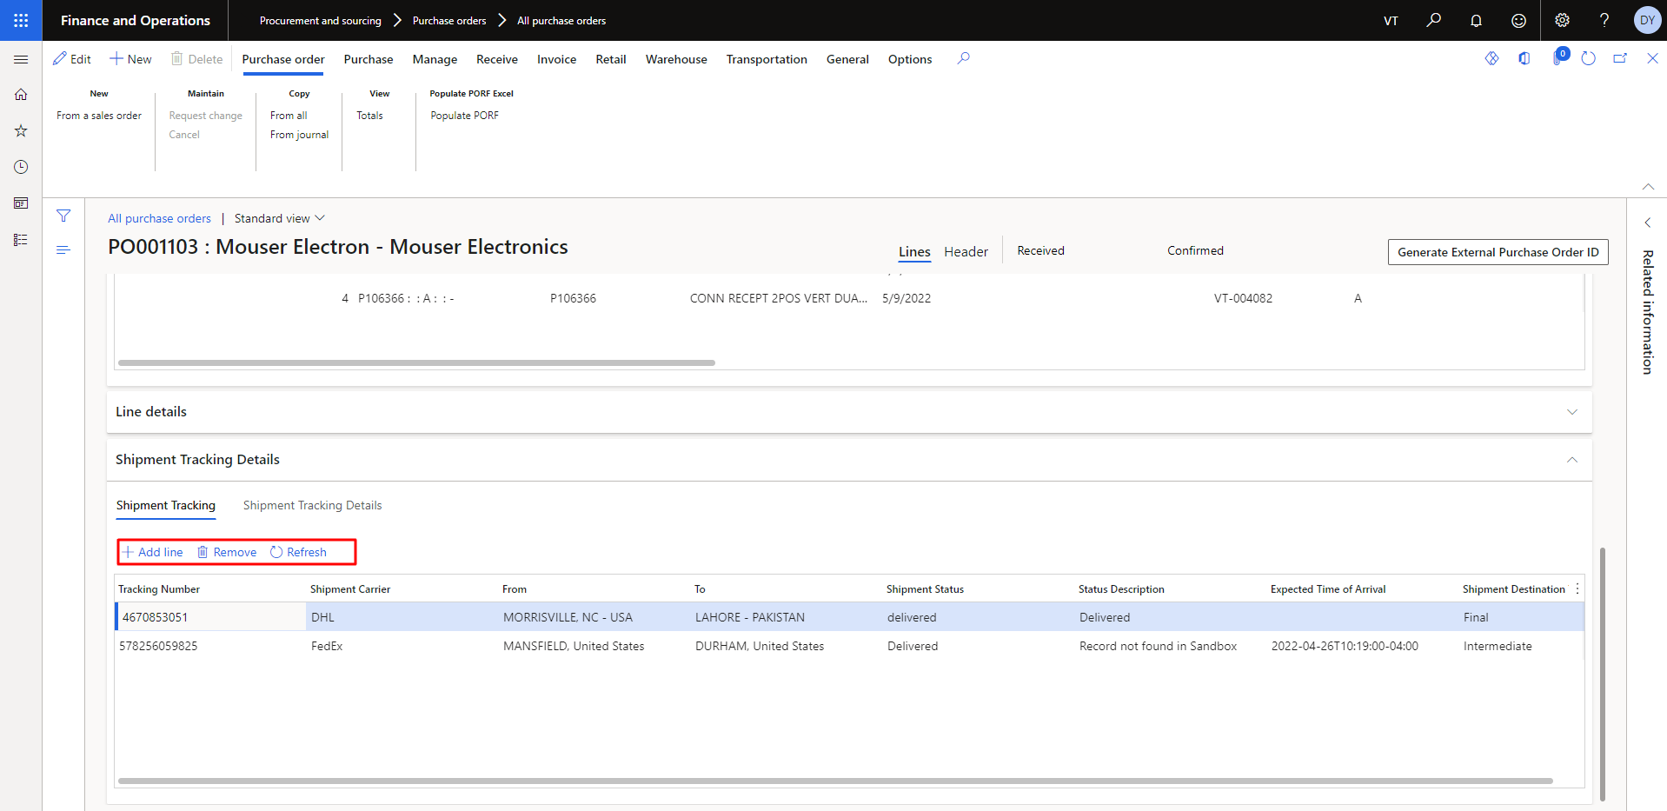

Figure 12 Shipment Tracking of Purchase Order

The user can also find the specific tracking number by using the filter option.

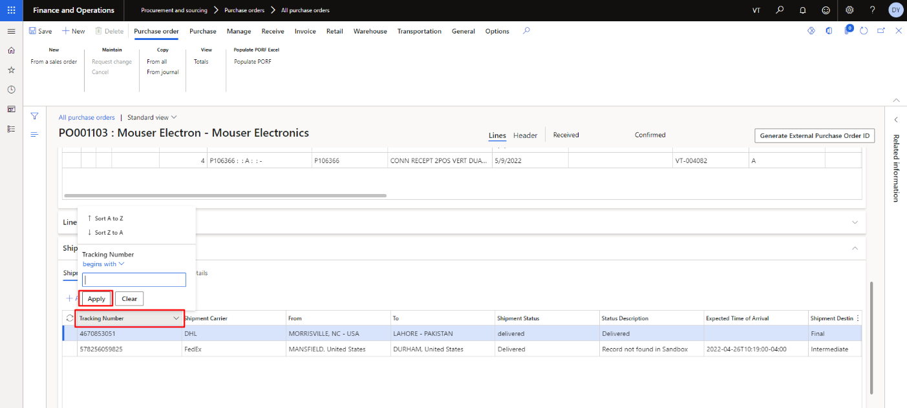

Figure 13 Apply Filter to find Tracking Number of Purchase Order

When the user is new then user must have to add the tracking number and shipment carrier.

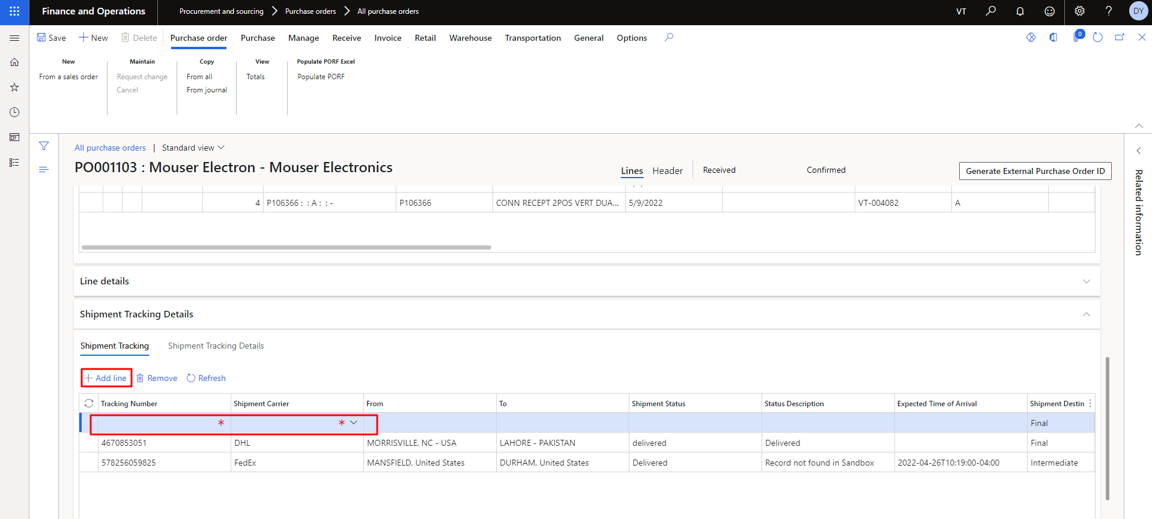

Figure 14 Add New Line of Shipment Tracking

The user adds the tracking number is already in the list.

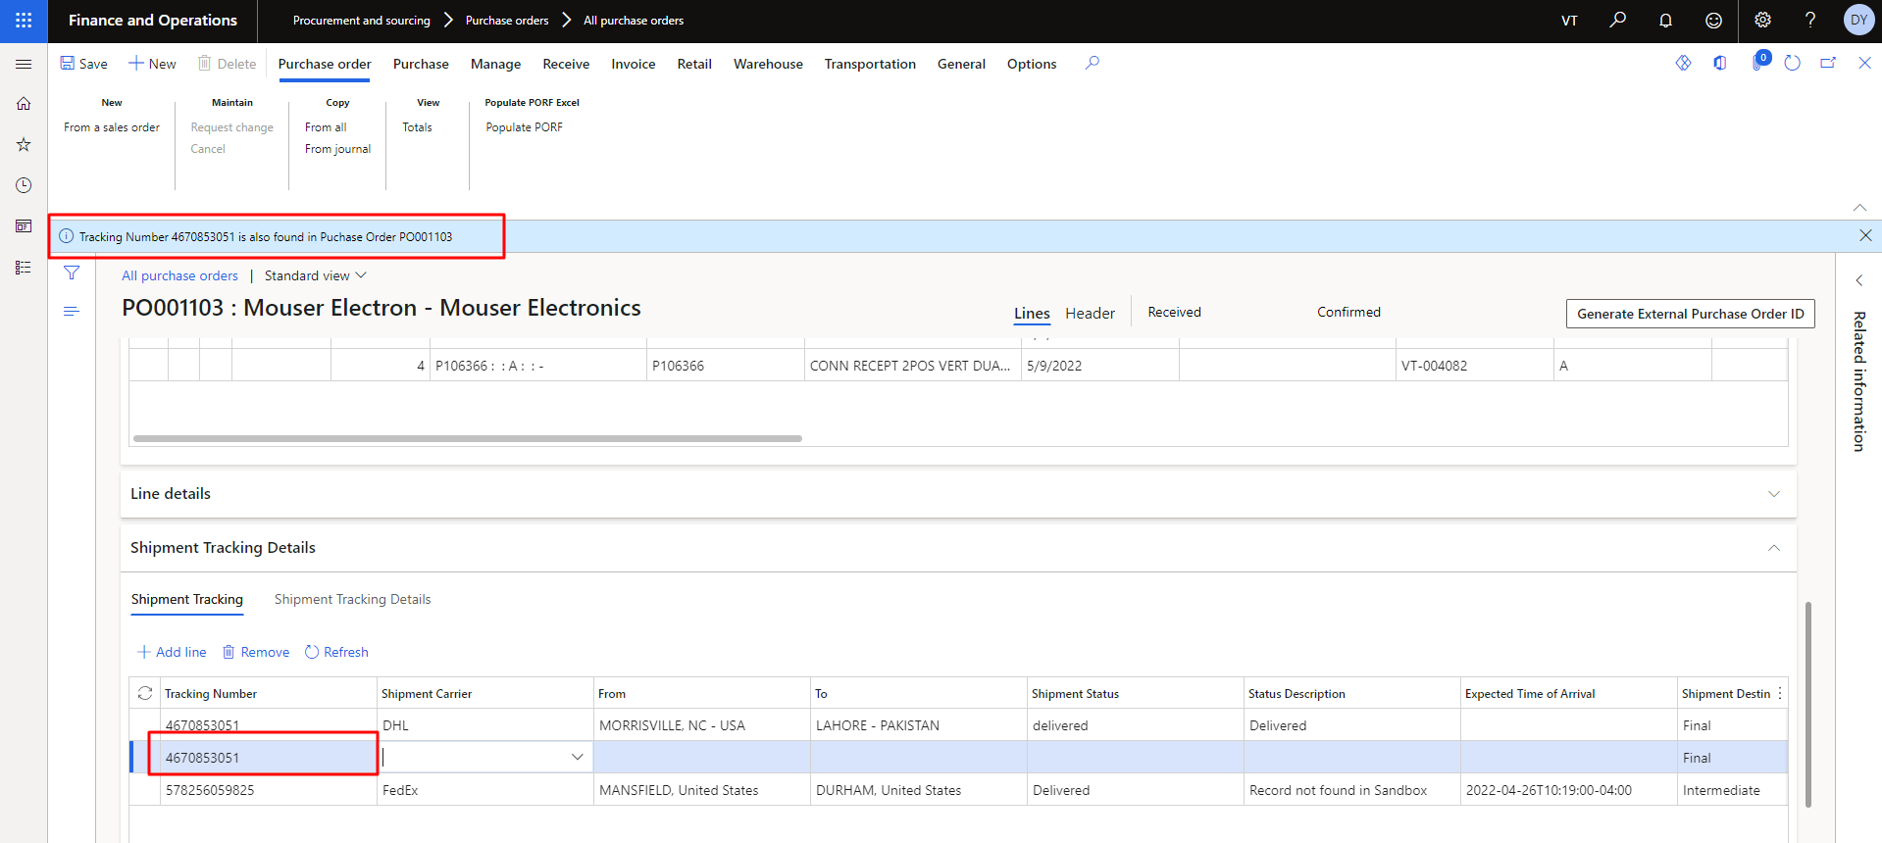

Figure 15 Alert if Tracking Number Already in the List

The user can’t add the shipment carrier if it’s associated tracking number already in the list.

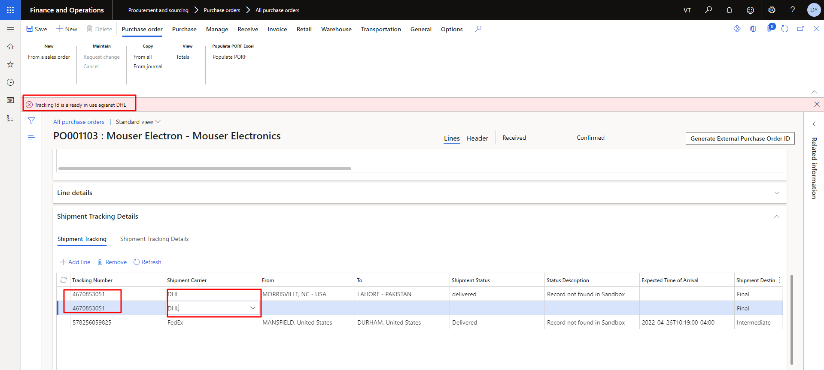

Figure 16 Alert If Shipment Carrier Already Associated

When the user adds, correct the tracking number and its associated shipment services only then it will be added and get all the detail related to it.

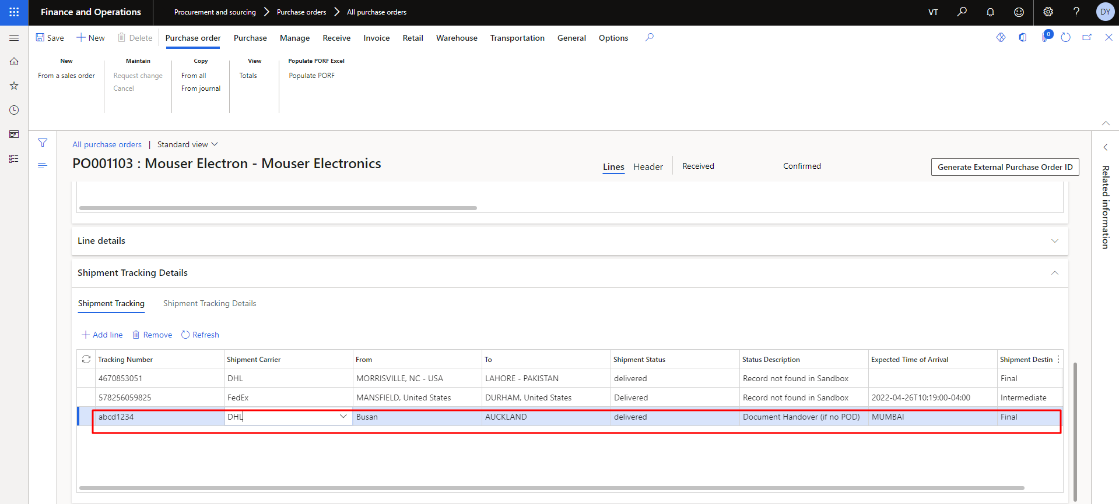

Figure 17 Correct Tracking number is Added Successfully

Then user need to select the specific tracking number then click on remove button to delete. It will be deleted after confirming the ‘**Yes’** from the popup.

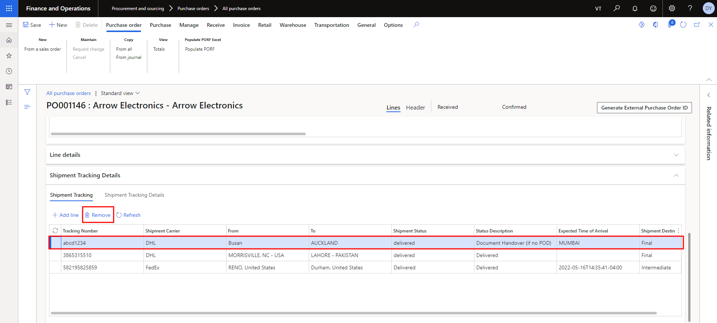

Figure 18 Remove Tracking Number from the List

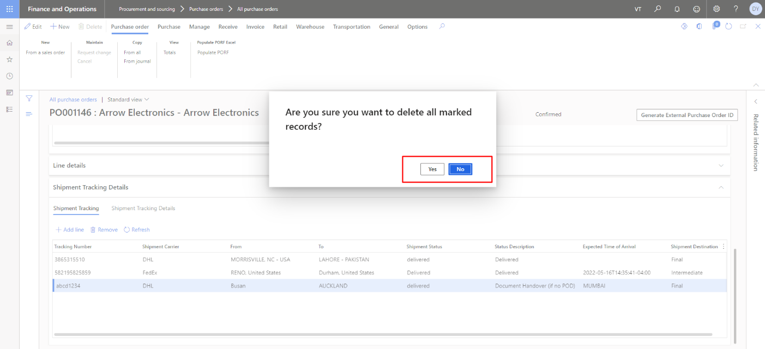

Figure 19 Confirmation Popup to Remove the Tracking Number

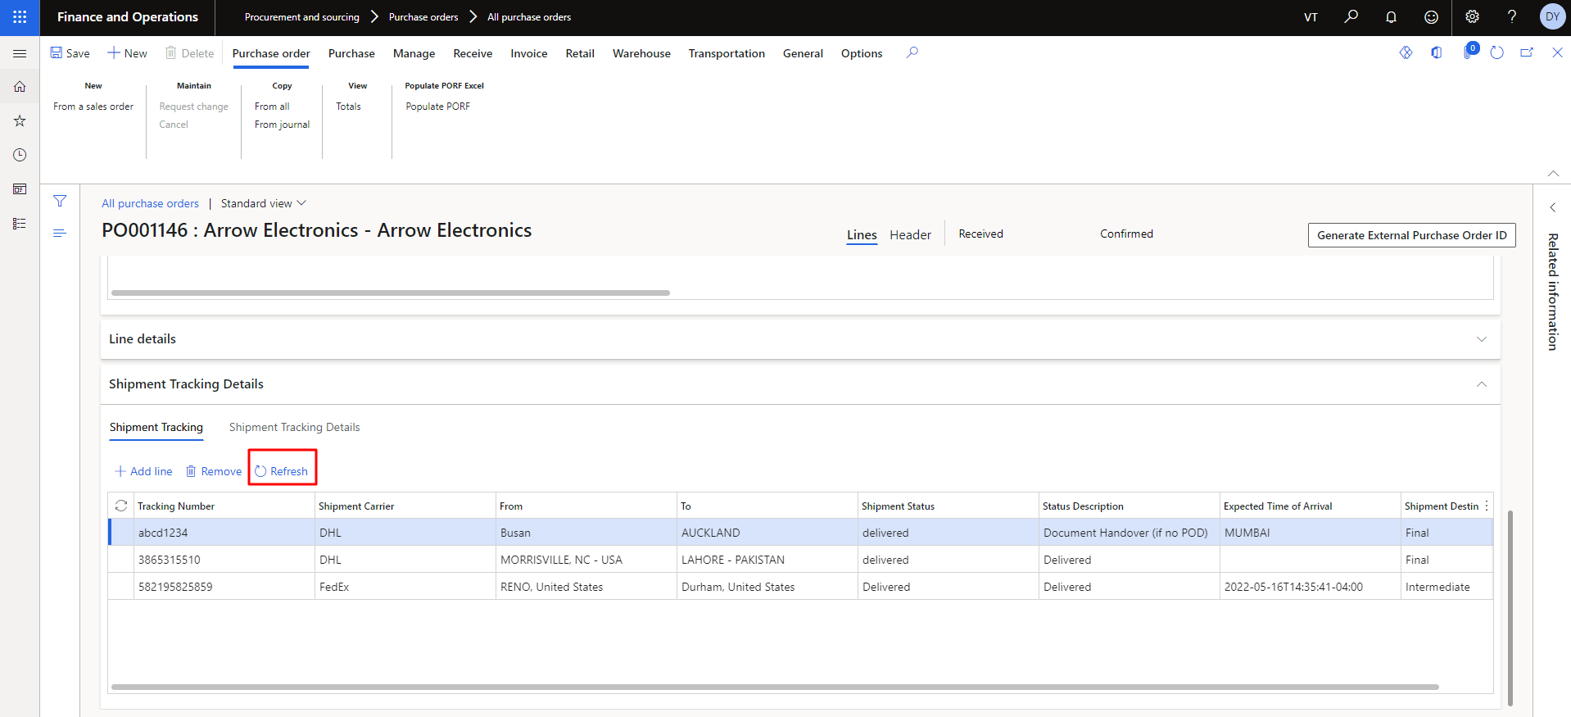

Figure 20 Refresh the Tracking List

## Shipment Detail

The user needs to follow the below flow to open the shipment details.

**Navigation**: Modules> Procurement and Sourcing > Shipment Tracking Details > Shipments

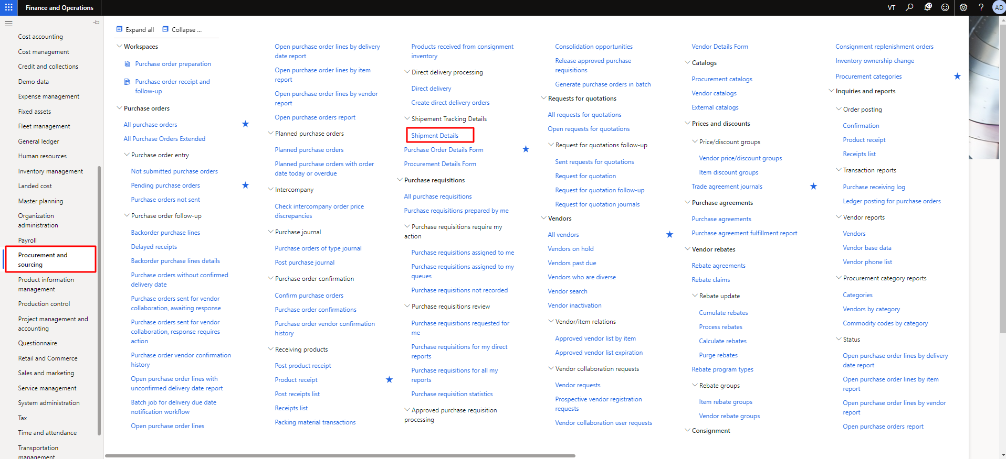

Figure 21 Shipment Details

The user needs to click on show all shipment detail to view all shipments.

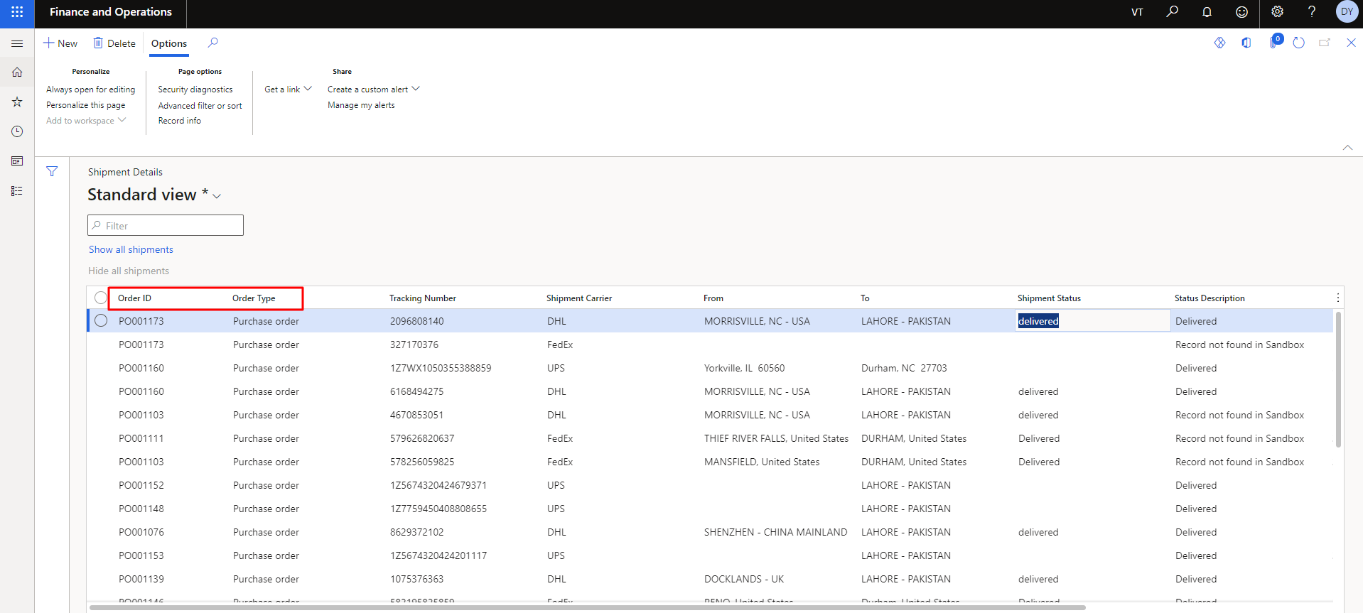

Figure 22 All Shipment Details

## Shipment Tracking Details

The user can access the shipment tracking detail of the of purchase order (PO) by opening the any specific purchase order. In the shipment tracking user can add new, remove and refresh it. The user sees the selected Part number from shipment tracking. Tracking number and shipment carrier in the top fields of shipment tracking details. In the shipment tracking detail user can’t add shipment tracking more than quantity of purchase order. The user can also remove any tracking number from the list as well refresh the list of tracking number.

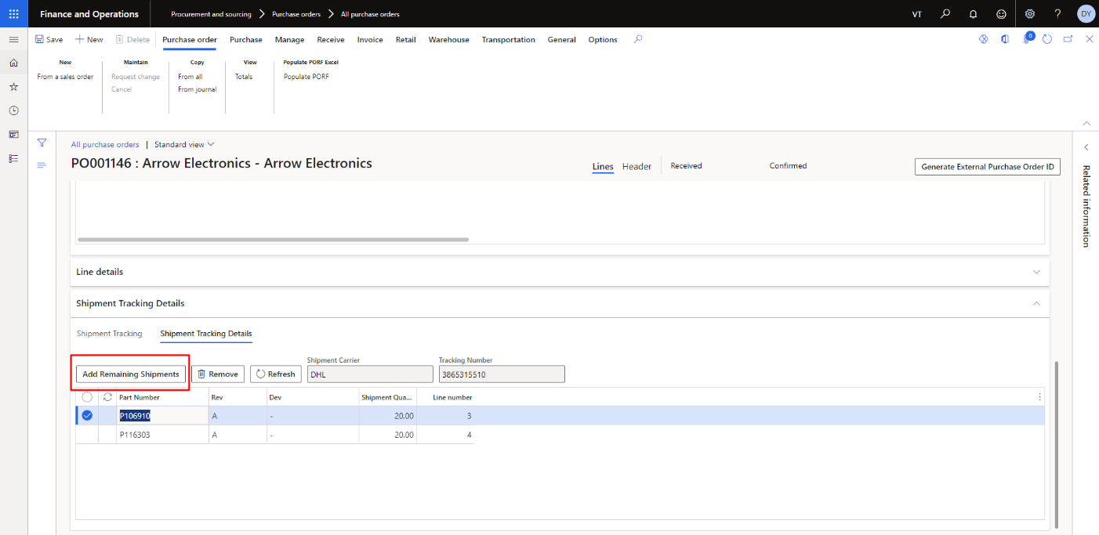

Figure 23 Add Remaining Shipment in the List

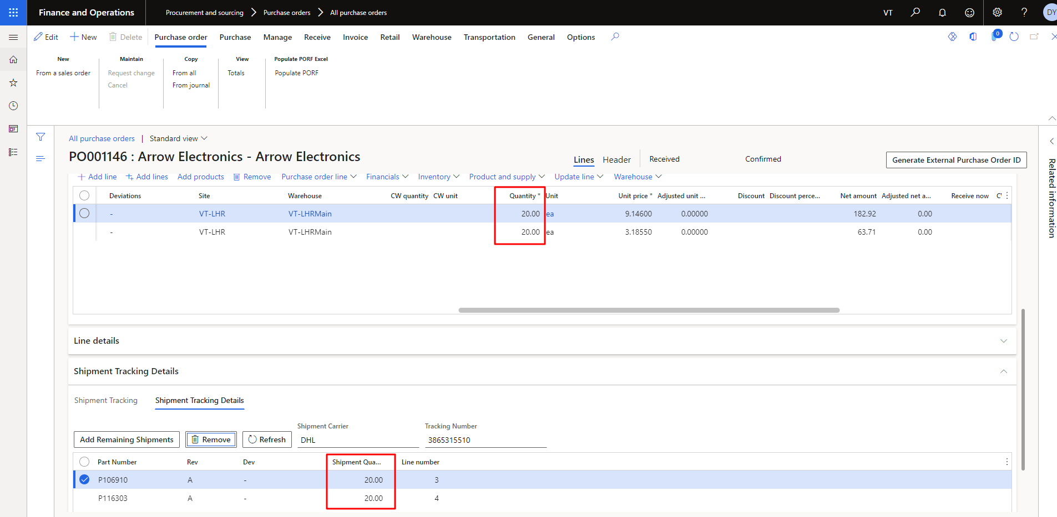

Figure 24 Comparison of Quantity of Purchase Order and Shipment Quantity

In the shipment tracking detail user can’t add shipment tracking more than quantity of purchase order.

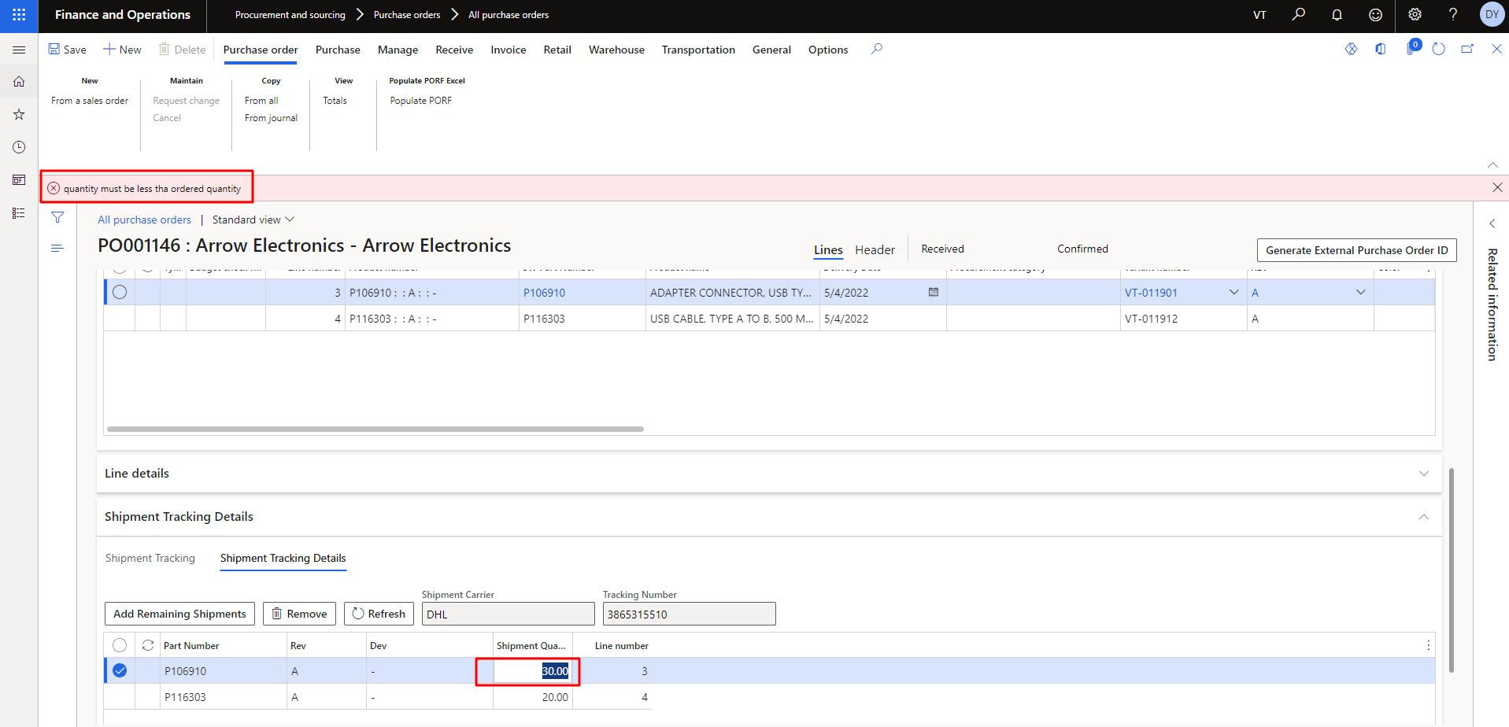

Figure 25 Shipment Quantity Must Les Then Order Quantity

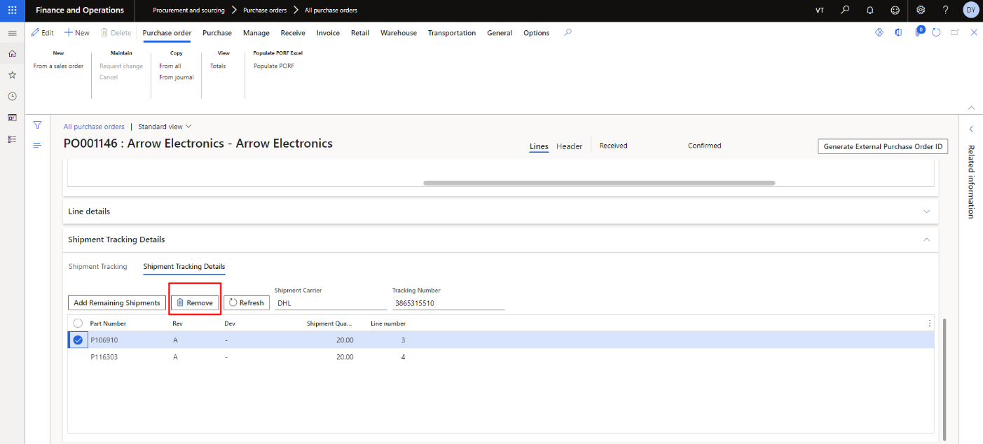

Figure 26 Remove any Part Number from the List

Then user need to select the specific tracking number then click on remove button to delete. It will be deleted after confirming the ‘**Yes’** from the popup.

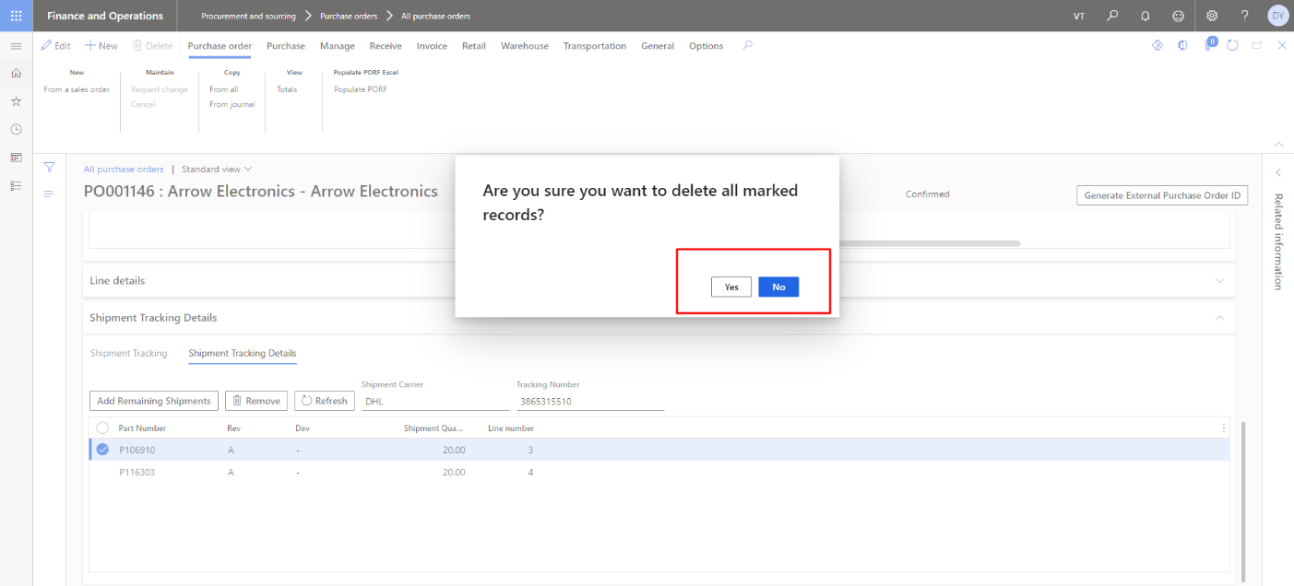

Figure 27 Confirmation Popup to Remove the Part Number from the List

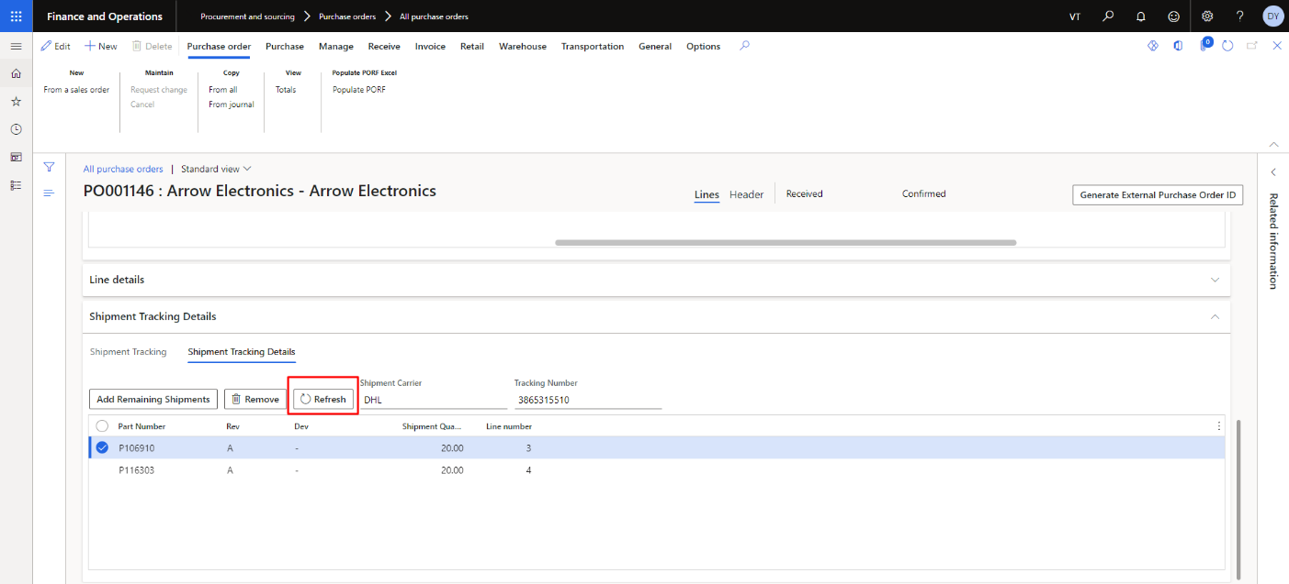

Figure 28 Refresh the List of Part Number